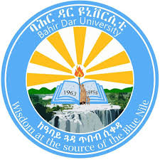

BAHIRDAR UNIVERSITY
BAHIRDAR INSTITUTE OF TECHNOLOGY
FACULTY OF COMPUTING DEPARTMENT OF SOFTWARE ENGINEERING
COURSE: OPERATING SYSTEM AND SYSTEM PROGRAMING
INDIVIDUAL ASSIGNMENT

NAME :ARSEMA SEMAHEGN
ID NUMBER :BDU1701598
SECTION :B
INSTITIUTION:BAHIRDAR UNIVERSITY
SUBMITTED TO :MR .WENDMU BAYE
SUBMISSION DATE: 20/08/2018 E.C

Abstract
This work offers a detailed and practical tutorial of installing Debian 13 in a virtual machine using Oracle VirtualBox. The goal of this project is to comprehend and simulate the process of installation of operating system, virtualization and setting up of the operating system in a controlled environment. The first step of the project is the setting up of virtual machine then installing the OS with the help of GUI interface, the procedures for partitioning hard drive, setting up user account and selecting the available software, setting up the bootloader, among others, are elaborated one by one. The advantages and disadvantages of Debian, difficulty in installation and suggestions for future improvement is also discussed in the document. From the findings it is observed that Debian is a secure, stable, and efficiently working OS and is a good fit for both educational as well as professional purpose. This practical work not only builds up the technical skills but also provides practical know-how.

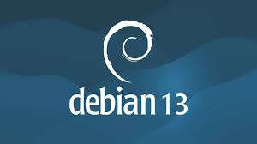

Table of Contents
Abstract 2
INTRODUCTION 4
BACKGROUND 4
Motivation 4
OBJECTIVES 5
REQUIReMENTS 6
INSTALLATION STEPS 9
ISSUES (PROBLEM FACED) 22
FILESYSTEM SUPPORT 24
ADVANTAGE AND DISADVANTAGE 26
CONCLUSION 28
FUTURE OUTLOOK AND RECOMMENDATION 29
VIRTUALIZATION IN MODERN OPERATING SYSTEM 30
References 33

INTRODUCTION
Debian 13 is a free and open-source operating system based on the Linux kernel. It is a popular choice for servers, desktops, and development systems due to its stability, security and long-term support. Debian is maintained by a large community of developers from all over the world. Unlike commercial operating systems, Debian does not have a vendor.
Virtualization is one of the essential technologies in modern computing, that allows running multiple operating systems on a single physical machine. Oracle VirtualBox is one of the most popular virtualization tool that let the users to efficiently create and manage virtual machines and allows testing and installing operating systems without impacting host system.
This document is the instruction set about how to install Debian 13 in Oracle VirtualBox with detailed step-by-step. It is focused to provide users the practical knowledge about operating system deployment.

BACKGROUND
The Linux Operating System came up as an open-source alternative to proprietary operating systems, which provides a great deal of flexibility, security and customizability. Out of various Linux distributions available, Debian is considered one of the oldest and most stable distribution which was released in 1993. This OS is one of the first few distributions and basis of many other distributions like Ubuntu.
Debian follows a well-defined release cycle. This ensures that every release passes through vigorous testing before being released. The downside of such approach is slower release compared to other Linux distributions but highly stable in production environments.
The virtualization technology like Oracle VirtualBox is being very widely used to simulate the different Operating system on the same physical machine and hence provides the very best way for a student, developers and system administrator to explore different operating systems without fearing for the Host OS.
The pair of Oracle VirtualBox and Debian would provide us an extremely good way to understand Operating system's Installation, Administration, and Linux-based development.

Motivation
The motivation of doing this practical work is to attain practical exposure of operating system installation and virtualization technology. To have a thorough understanding of how an Operating system is installed and configured would certainly be beneficial to a student in Computer science and IT fields.
Additional motivation is the use of Debian OS which is known to be stable, secure and vital for various applications that can be applied to production environments such as server farms and cloud servers and would make one comfortable with the Linux environments which is widely used all over the world.
The last motivation would be to learn the use of Oracle VirtualBox as virtualization tool and how virtual machines can be utilized as virtual environments in which one can perform experiments on the operating system without affecting the host OS.

OBJECTIVES
General Objective:
The main objective of this project is to install, configure and document the Debian 13 OS in a virtual environment and achieve a detailed understanding of its operations, features and system architecture.
Specific Objectives:
The specific objectives of this project are as follows:
1. OS Understanding
To appreciate the role and significance of an operating system in a computer system
To understand the mechanisms and operations involved in an OS managing resources (hardware/software)
2. Virtualization Understanding
To acknowledge the concept and benefits of virtualization in current computing
To understand how virtual machines imitate a real-world computer system
To appreciate the features and functions of VirtualBox as a virtualization software.
3. OS installation
To be able to download and prepare the Debian installation image.
To be able to create and set up a virtual machine.
To be able to install Debian 13 step by step using the graphical interface.
4. Configuration of the OS
To configure general OS settings such as language and locale, full name for the user and a new password and verify security policies, disk partition setup and any other required setting for the OS.
5. Documentation of installation
To take screenshots for every single installation step.
To provide a clear and structured explanation for each step performed.
To generate a neat technical document representing the installation process.
6. Identification of and solution for problems
To be able to report errors encountered during the installation.
To analyze causes and find appropriate solutions for the problems.
7. Understanding basic OS functions
To get familiar with Linux fundamental commands and navigation on the OS.
To understand the Linux file system hierarchy and layout.
To know basic file operations and be able to use APT to manage packages on the OS.
8. Academic and practical skill enhancement
To develop technical documentation capabilities.
To promote analytical thinking skills.
To increase practical and job oriented skills relevant to system administration

REQUIReMENTS
1 Hardware Requirements
Despite Debian being lightweight it does need enough hardware in host machine to be run in virtual machine.
Minimum Hardware Requirement
Processor (CPU) - Dual Core Processor (Intel/AMD)
RAM - 2 GB (minimum), 4 GB (recommended) for seamless run
Storage - 10 GB+ Free disk space.
Display - normal display monitor (minimum 1024768 resolution)
Recommended Hardware Requirement
Processor - Intel core i5 or greater
RAM - 8 GB and above.
Storage - 20 GB and above for good run and updations.
Virtualization Support-Enabled in Bios/UEFI (Intel VT-x/AMD-V)
Note
A Virtual Machine shares the resources with the host OS thus better CPU and RAM will improve the overall performance.
It will not work if ram is not enough to load and run virtual machine, leading to errors/failure in installation process.
2. Software Requirements
To install Debian in a virtual machine one will need following software to accomplish the setup.
1. Host Operating System
Host machine must be loaded with operating system from below:
Windows 10/Windows 11
Linux (Ubuntu, fedora..)
2. Virtualization Software
Virtualization software is required for creating and running virtual machines, In the present project the virtualization tool used is:
Oracle VM VirtualBox.
This software is used to create virtual machine and load the Debian OS into it so as not to tamper with the main host OS.
3. Debian ISO Image
Debian Installer (ISO file).
This file contains all the necessary components needed for the installation of Debian 13 and will serve as a bootable image in the virtual machine.
4. Internet connection.
It will be required for the download of
- Debian Iso Image
- Updates and software packages, during installation
5. Other tools (Optional)
Screenshot tool for the documentation
Text Editor / Ms word for report writing
3.3 Summary Table
Requirement Type | Component | Description
Hardware | CPU | Dual-core or higher
Hardware | RAM | 2GB minimum(4GB recommended)
Hardware | Storage | 10GB+ free space
Software | Virtualization | virtualBox
Software | Os image | Debian iso
Network | Internet | Required for updates

INSTALLATION STEPS
How to install Debian 13 ( Oracle VirtualBox )
In this chapter we have explained how to install Debian 13 on Oracle Virtual Box in a clear and step-by-step manner. Every single step in the entire installation process has been carefully monitored to facilitate the correct installation from the virtual machine's setup to the first login into the installed OS.
1. Creating the Virtual machine
We first began by creating a new virtual machine where Debian will be installed.
- Oracle Virtual Box was launched.
- The "New" button was clicked in order to start creating a new virtual machine.
- The following inputs were made:
- Name: Debian 13
- Type: Linux
- Version: Debian (64-bit)
- Subsequently memory (RAM) was allocated:
- Minimum allocated 2048MB(2GB)
- Recommended 4096MB(4GB) in order to increase the performance of the system
- A virtual hard disk was created after memory allocation:
- Hard disk type: VDI (VirtualBox Disk Image)
- Storage: Dynamically allocated
- Size: 20-30GB
This phase created a virtual machine ready for the installation of Debian 13.
(Insert your screenshot here)
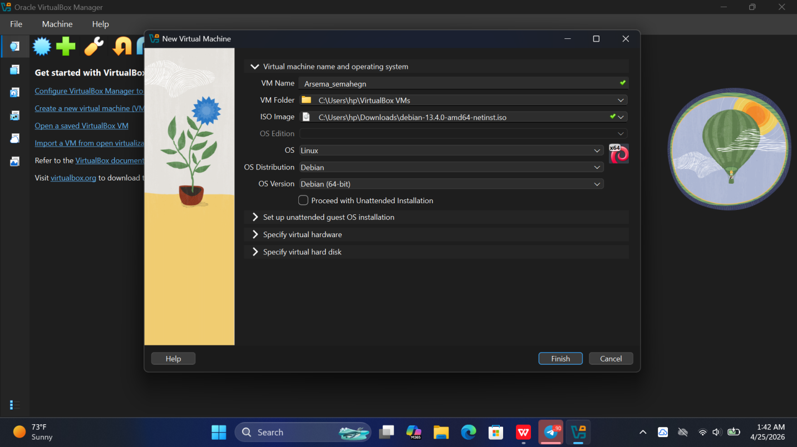
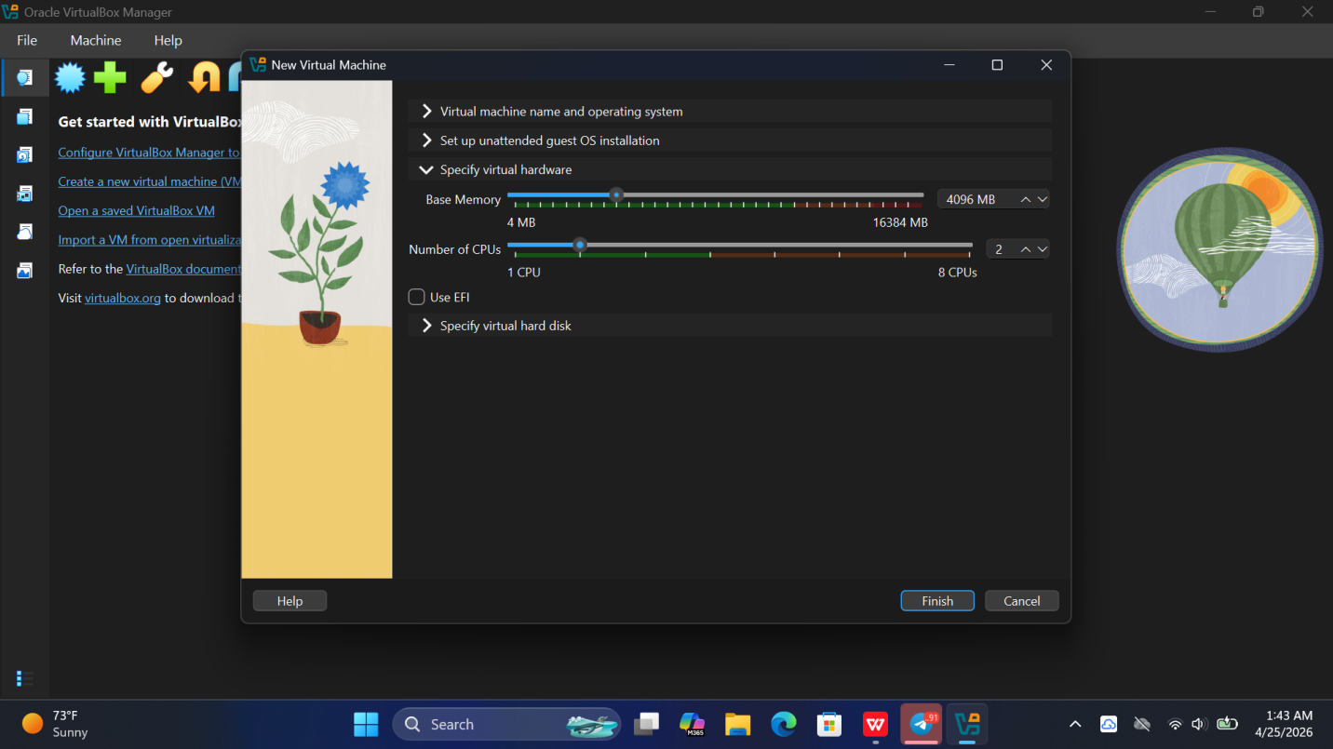
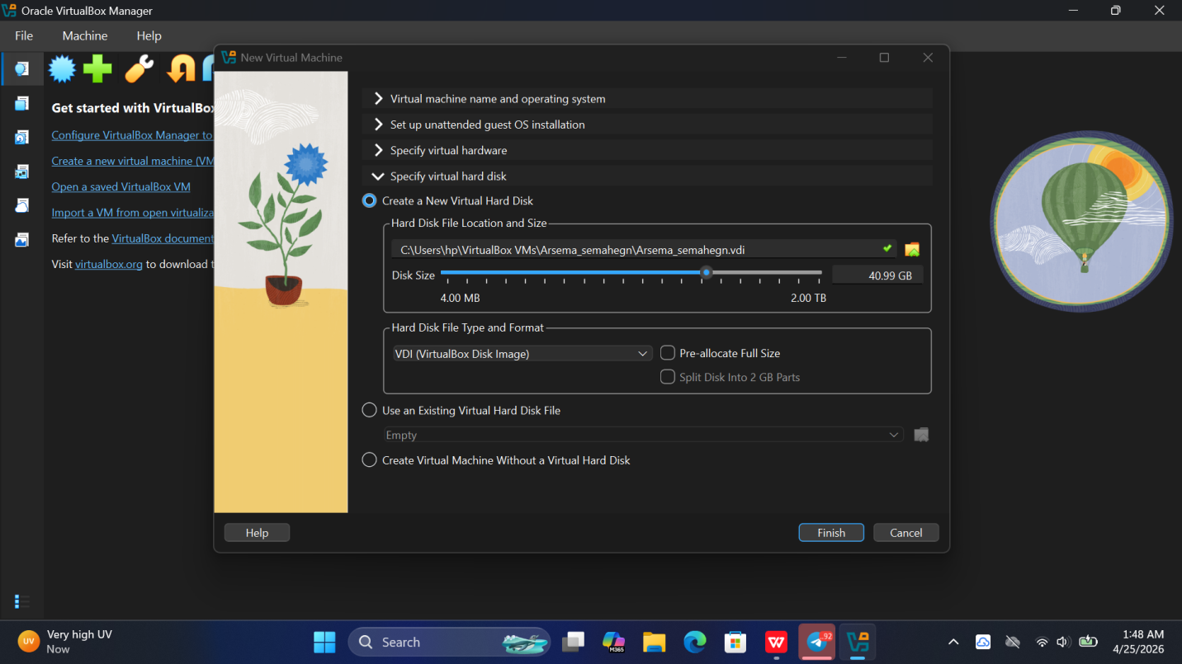
Figure 1:virtual machine creation in oracle virtualBox
2. Attaching the Debian 13 ISO file
The downloaded Debian 13 installation file was then attached to the Virtual machine.
- The newly created virtual machine was chosen.
- "Settings" was clicked.
- Under "Storage" and the blank disc,
- the blank disc was selected,
- the disc symbol was pressed
- and the Debian 13ISO file was selected.
This phase connected the Virtual machine to the Debian installation media.
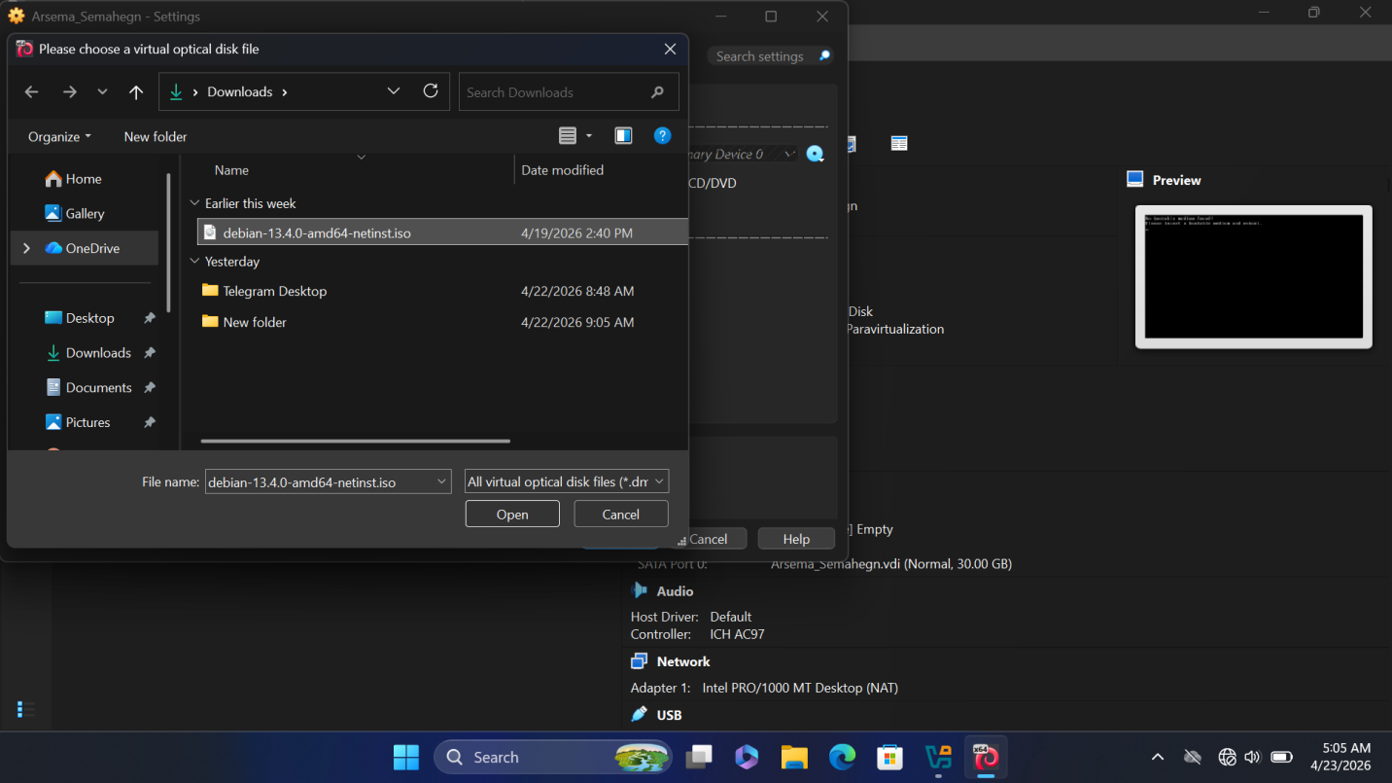
Figure 2:Attaching Debian 13 ISO File
3. Starting the installation
We began the installation of the operating system by turning on the virtual machine.
- The "Start" button was clicked.
- The Debian installation menu displayed itself.
- "Graphical Install" was selected.
We chose to install the system using Graphical Install since the text based installation would be difficult to manage and use.
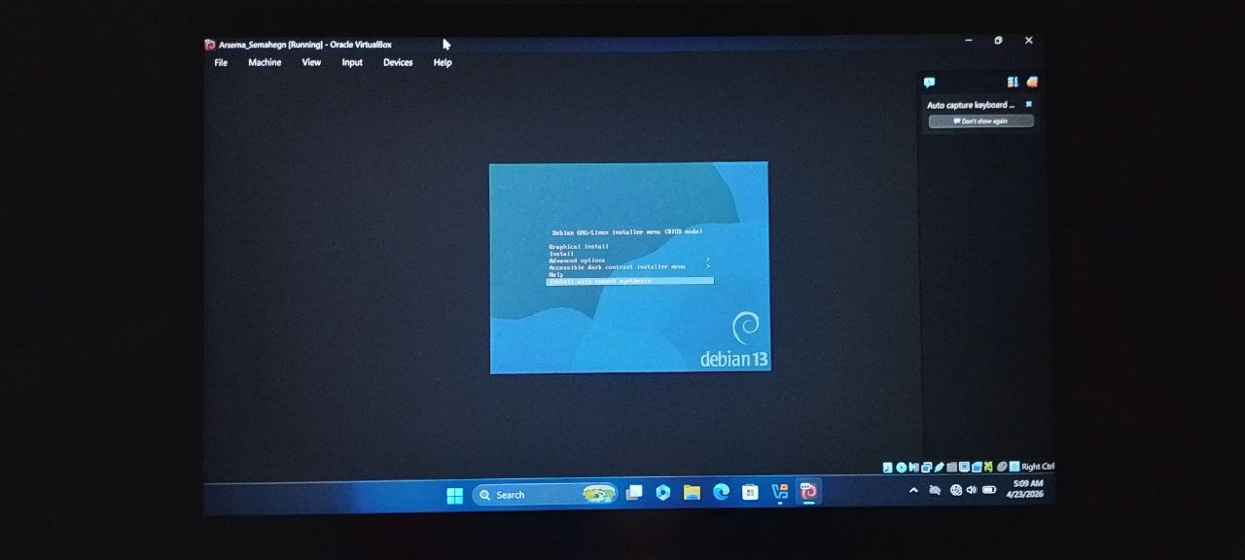
Figure 3:Debian Installation Menu
4. Selecting Language, Location, and Keyboard
In this phase the basic configuration settings of the operating system were set.
- We chose English as the system language.
- Ethiopia was chosen as the location and any appropriate location will work just fine depending on where the person using it is.
- "US English" was chosen as the keyboard layout and any correct option should be chosen based on where the person is using the system.
These settings were adjusted so as to configure the system's environment correctly.
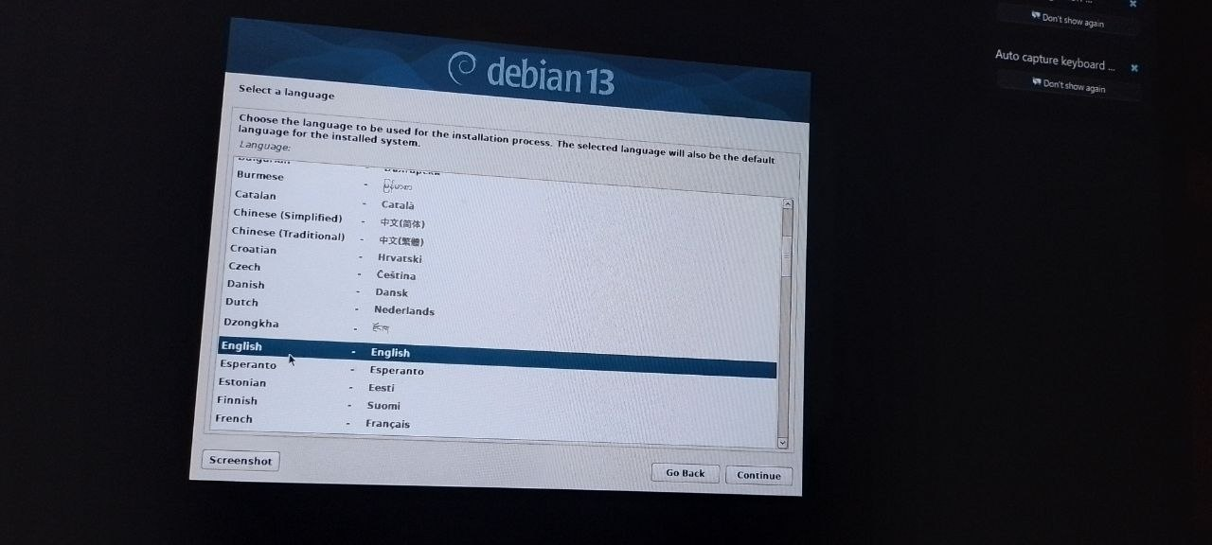
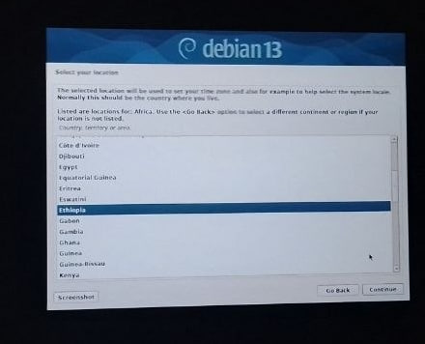
Figure 4:Language and Location selection
5. Configuring the network
Here we have the configuration of the operating system's network.
- We were asked for the system hostname and decided to type "debian-pc" and the domain name was not set.
The hostname is essentially the system's identity on the network.
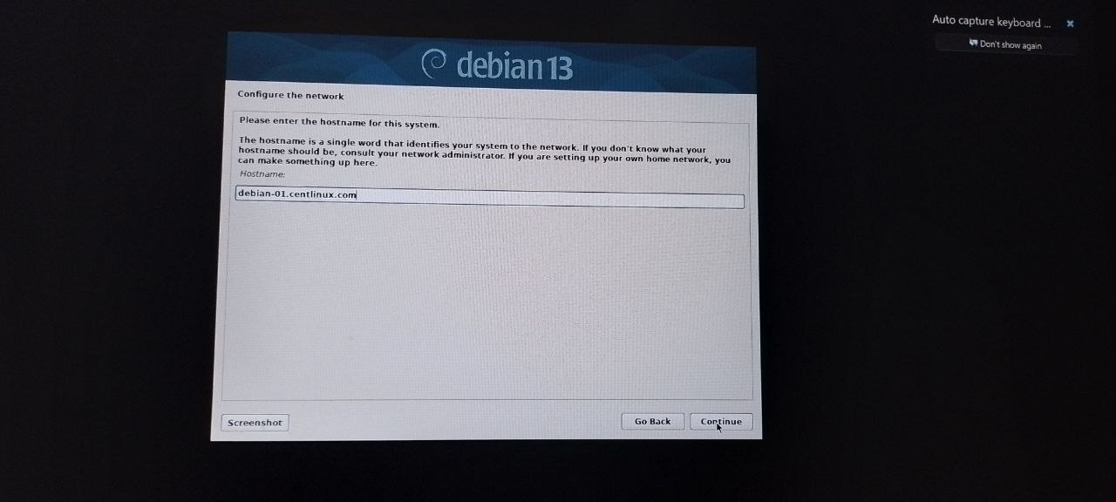
Figure 5:Network configuration Screen
6. Setting up users and passwords
In this stage we have configured user accounts for accessing the system.
- A password was set for the root user which allows privileged access to the system and also for the system administrator's user.
- For the system administrator:
- Full name was added
- User name was chosen (which was based on the full name added)
- A password was added
This stage secured the user's access to the installed OS.

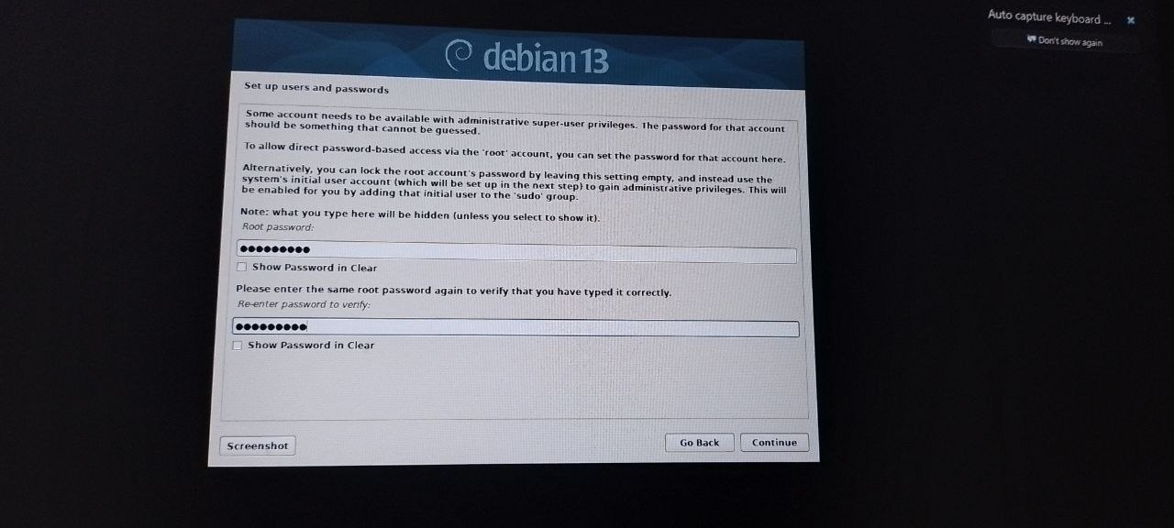

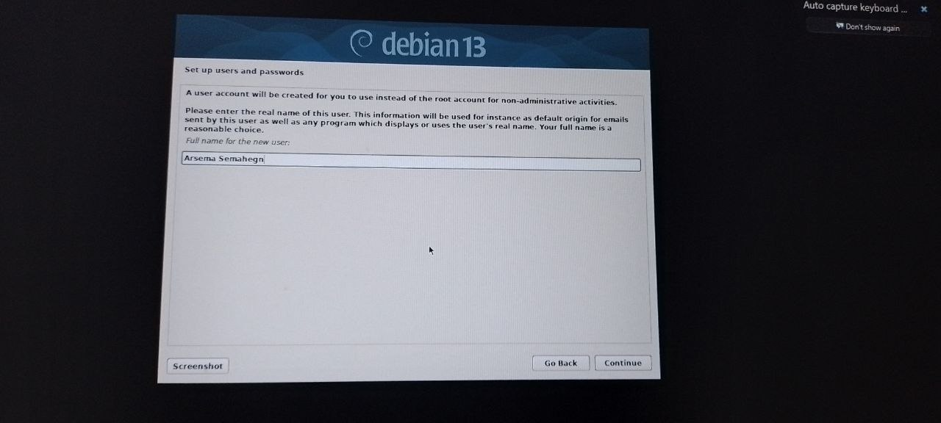
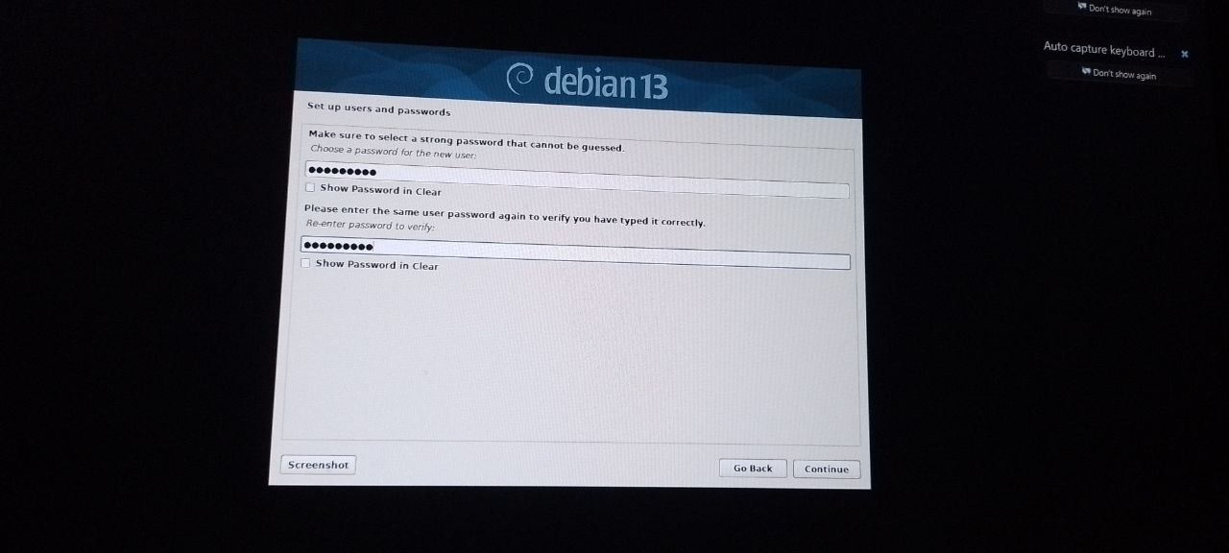
Figure 6 :User account setup
7. Partitioning of the disks
Here, the storage of the operating system was prepared for installation.
- "Guided - use entire disk" was selected and the appropriate disc chosen.
- The partition scheme displayed "All files in one partition".
- Changes were confirmed.
This configured the virtual machine's hard drive for the installation.
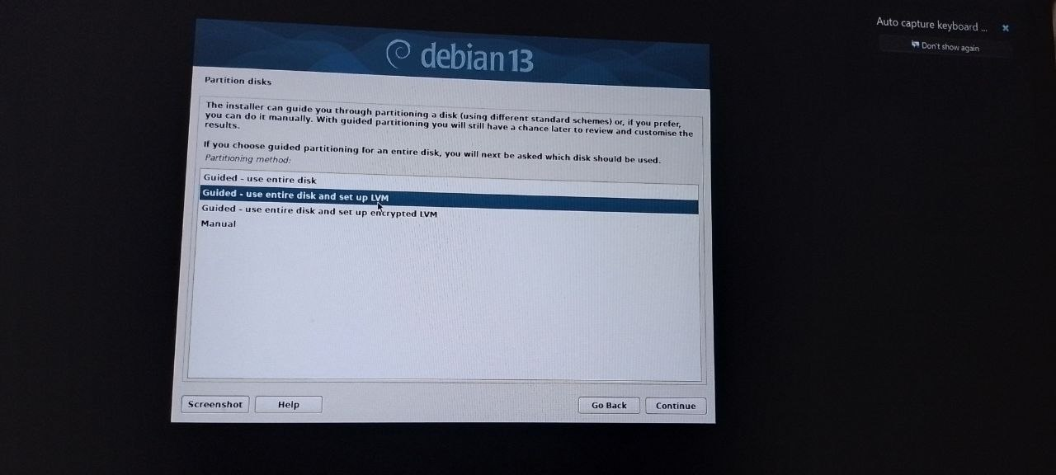
Figure 7:Disk partitioning process
8. Installing base system and packages
During this part of the installation, the operating system began to set itself up by downloading files and then installing them.
- Base system and files were installed without intervention.
- All the necessary packages for the installation to continue were downloaded and installed.
The installation here may seem to take long depending on the performance of the system you are using.
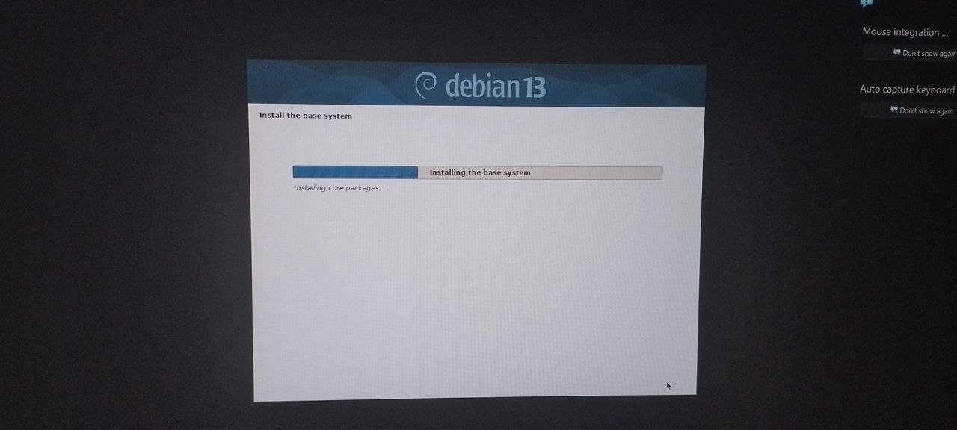
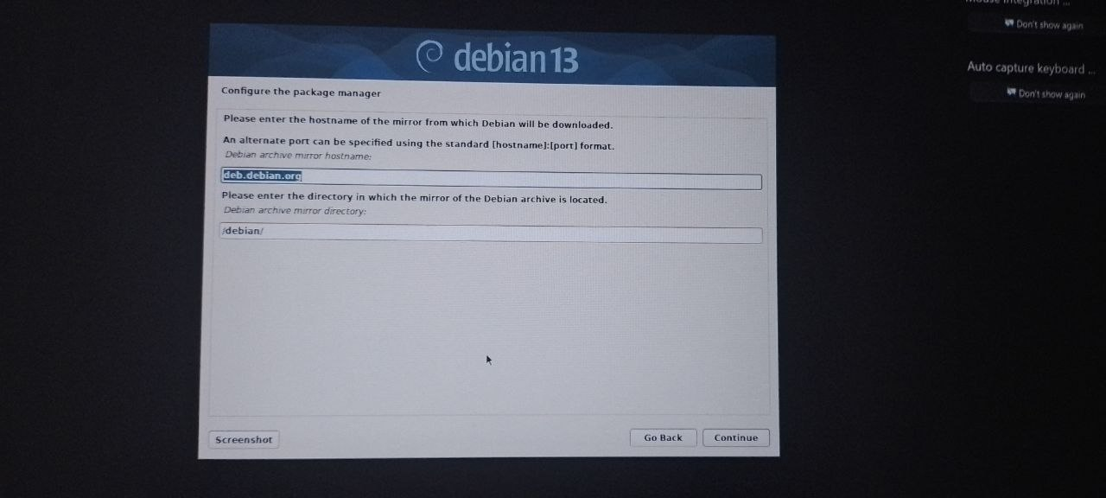

Figure 8:Package installation progress
9. Choosing Software and Desktop environment
This part of the installation determined what components the OS will have.
- A desktop environment of choice was chosen from the list below:
- GNOME (This is selected by default and is good for beginners)
- Others like KDE, XFCE, etc. Can be chosen instead.
- Standard system utilities were selected.
If no desktop environment is chosen, the system will install itself without any Graphical User Interface.
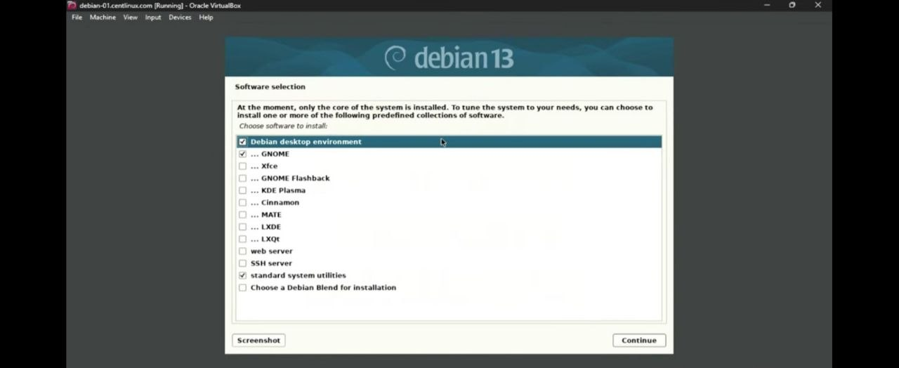
Figure 9 :Software Selection Screen
10. Installation of the boot loader
GRUB was installed onto the disk of the operating system.
- "Yes" was chosen on whether to install the GRUB bootloader.
- The location was automatically configured and assigned to /dev/sda.
GRUB is what allows you to boot into your operating system without being forced to load the installation disk.
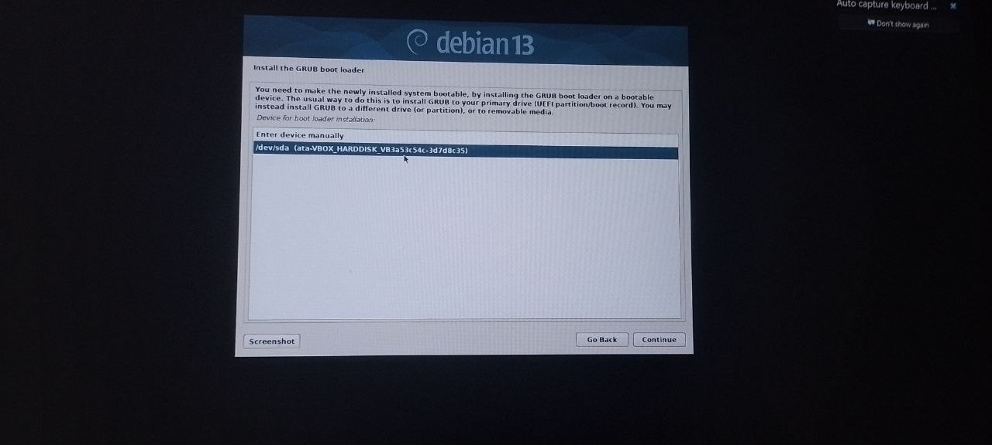
Figure 10 :GRUB Bootloader installation
11. Installation completed
The system configuration was completed and finalized.
- The system displayed the message "Installation complete." and requested the machine to be rebooted.
- The ISO file was removed before rebooting to prevent the installation media from booting again.
The installation of Debian 13 on the virtual machine was a success.
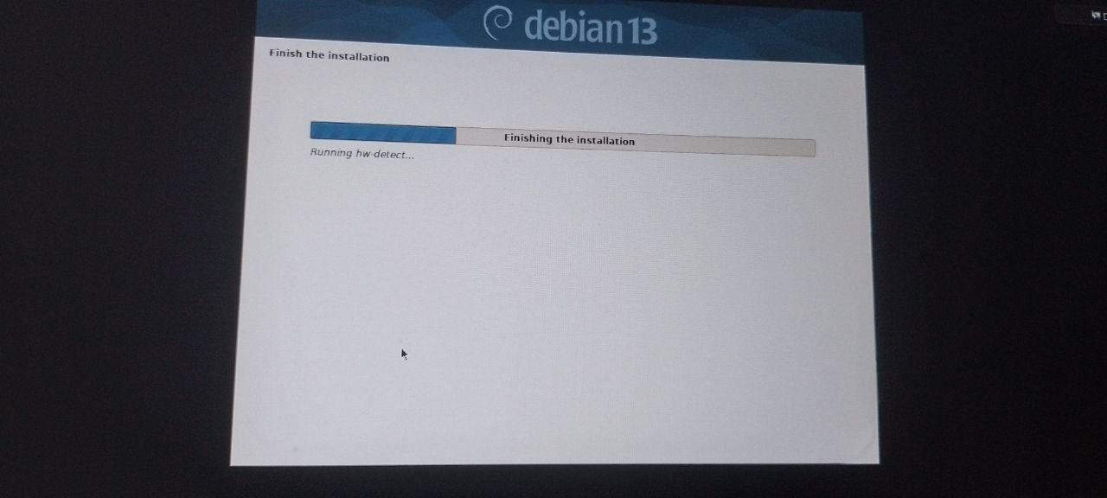
Figure 11 :Installation complete screen
12. Logging in for the first time
Once the virtual machine was rebooted, the login screen appeared.
- The login information (username and password) were then entered to gain access to the installed operating system.
The Debian desktop environment was displayed.
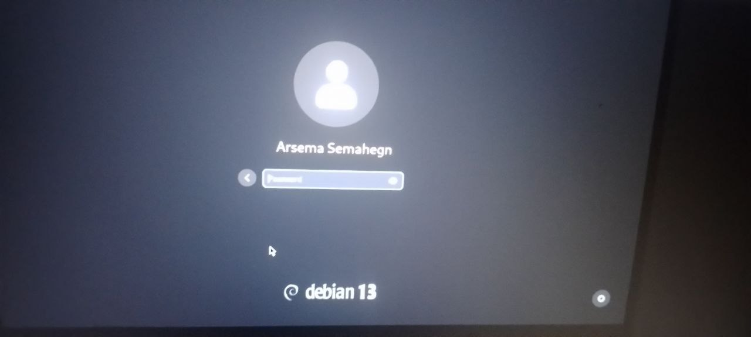
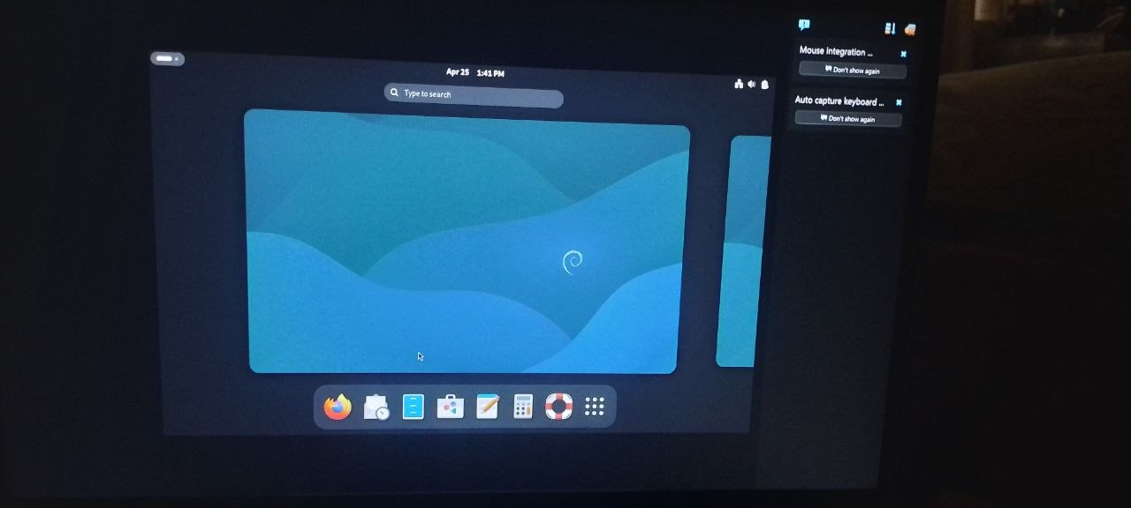
Figure 12 :Debian login screen and Debian Desktop GUI

13. Post installation configuration
The system's configuration was complete, but now it was time to prepare the operating system for daily use.
- The system was updated.
- The terminal was launched and the following lines typed:
cat /etc/os-release
uname -r
hostname
sudo apt update
sudo apt upgrade
-Virtual box guests Additions were added for the system to have improved resolution and performance.

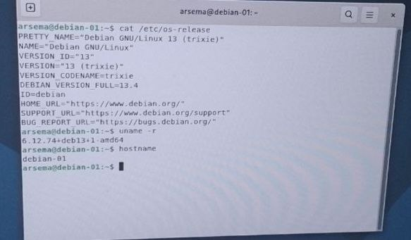
Figure 13:System update via terminal
Summary of installation
The installation of Debian 13 on VirtualBox has been a success following a clean and orderly process. All the necessary procedures have been followed to establish the operating system to the point of use with relative ease. The guided setup process made it easy to install the system, however, specific stages require full attention during the setup.

ISSUES (PROBLEM FACED)
5. Problems and their solutions
Some problems could arise while installing Debian 13 in an Oracle VM Virtual Box. Here some problems and how we solved them.
5.1 Problem: System could not be started up after installation
Description: The system got back on the installation page instead of starting the OS after finishing the installation
Cause: ISO was still attached on the virtual box
Solution: Open the Virtual Box, open settings, then storage and detach the Debian ISO file and startup the VM.
5.2 Problem: Black screen after installation
Description: After reboot, there was a black screen
Cause: Display setting issue / GUI missing
Solution: Restart the VM and check the display setting within Virtual Box / check for installed desktop environment.
5.3 Problem: No Graphical User Interface (GUI)
Description: Only a terminal opened after finishing the installation, no desktop environment was shown.
Cause: No Desktop Environment was selected in the installation step.
Solution: After the install, open the terminal and write
sudo apt update
sudo apt install tasksel
sudo tasksel
select then Desktop environment (GNOME) and press enter.
5.4 Problem: Could not locate package
Description: This problem shows as "could not locate package."
Cause: The system has not updated the package list.
Solution:
sudo apt update
5.5 Problem: Slow execution
Description: When executing the system was extremely slow.
Cause: Low allocation of RAM / CPU usage is too high on the VM
Solution: Increase the RAM (minimum 2GB or 3GB) / increase the CPU resources on Virtual Box Settings
5.6 Problem: Password does not work
Description: Cannot login after setup.
Cause: False password or issue with the keyboard layout.
Solution: Make sure to type the correct password and verify the keyboard layout or type the password with root.
5.7 Problem: Freezing during installation
Description: The system stops at a certain step and gets frozen.
Cause: Lack of RAM, CPU, faulty ISO.
Solution: Restart installation ,download again the Debian ISO, increase RAM allocation.
Conclusion
Problems during OS installation can be frequent and common. Having a solution ready to address these issues will develop the troubleshooting skill and practical knowledge on how to install OS on Virtual Machine.

FILESYSTEM SUPPORT
6. File System Support in Debian
Debian is an operating system that supports numerous file systems used for storing and organizing data. The data is kept in some storage devices like hard disk, virtual disks, etc. A file system represents the way in which data is organized and maintained on a disk drive.
6.1 Frequently used File Systems in Debian:
1. Ext4 (Extended File System 4): It is the default file system used in Debian. Its characteristics include high performance and reliability, the ability to store large size files and large sizes of storage devices, and journaling (which ensures data integrity after system crashes). Usually, this file system is selected at the time of installation.
2. Ext3: It is the predecessor to ext4 and supports journaling; it is also reliable though relatively less efficient.
3. FAT32 (File Allocation Table): It is a widely compatible file system for Windows and many other systems, typically used in external storage devices and flash drives. One limitation is that individual files can't be more than 4 GB in size.
4. NTFS (New Technology File System): This is the default file system used in Windows. Debian is capable of read-write support for this file system, thanks to drivers. Useful for dual-boot scenarios.
5. Swap File System: This is used as a virtual memory and takes effect when all the available RAM is utilized; it's automatically created during installation.
6.2 File System structure in Debian:
In Debian, the data is stored using a hierarchy of directories, which starts from the root directory /(slash).

Main Directories:
Directory | Description
/ | Root directory (main folder)
/home | User files and personal data
/etc | Configuration files
/bin | Essential system commands
/usr | Installed applications
/var | Log files and variable data
/boot | Boot file

6.3 File system used in the project
- When installing Debian 13:
- The file system used is the ext4 one
- The guided partitioning tool has been used
- A swap area was automatically created
All of these give an effective system performance and security in the management of data.
6.4 What a file system is and why is it important
- Efficient organisation of data
- Data security and integrity
- Good performance of system
System interoperability with other operating system

ADVANTAGE AND DISADVANTAGE
Advantages
Debian 13 is well known as one of the most stable, as well as reliable, Linux distributions out there. Debian is geared towards a stable, secure system and long term usability of the system. The primary advantages of Debian 13 are:
1. Highly Stable System
The biggest advantage to using Debian is the incredibly high stability of the system. All releases undergo extensive testing before they are declared "stable". This greatly reduces the risk of system crashes and software failures, making Debian an excellent operating system for servers, academics, as well as production environments.
2. Strong Security Framework
Debian provides users with a great deal of security with consistent security updates and patches being issued promptly. The Debian Security Team is vigilant in monitoring vulnerabilities and making security updates available to users.
3. Free and Open-Source Nature
Debian is an absolutely free and open-source operating system. There are no licensing fees when using Debian, which greatly encourages experimentation and ease of distribution. Transparency is key to FOSS.
4. Large Software Repository
With tens of thousands of precompiled packages available, Debian boasts one of the largest software repositories. Users can readily install software using a package manager such as APT.
5. Efficient Resource Utilization
Compared to most of today's operating systems, Debian utilizes relatively little resources. It can run quite comfortably on low-end hardware and/or older machines. Debian is an ideal OS for virtual machines with resource restrictions.
6. Strong Community Support
Thanks to its longevity and popularity, Debian has a massive and helpful community of users and developers. Support is readily available in the form of documentation, forums, and mailings lists, and helps with both minor and major issues.
7. Ideal for Learning and Development
Debian is widely used in academics as well as by software developers. It is one of the simplest OS to learn about system administration and the Linux structure with the strong Linux foundations provided by Debian.
Disadvantages
While Debian has a lot to offer, there are drawbacks that make it less ideal for new or even moderate users wanting to explore the newest things:
1. Not Beginner-Friendly
It is well known that Debian is an operating system that should be used with caution by new users to Linux. While installation isn't particularly difficult, configuration and troubleshooting often require using the terminal which can be daunting for someone only accustomed to a graphical interface.
2. Older Software Versions
To ensure system stability, the software contained within a stable Debian release is sometimes outdated. New users or those wishing to utilize the latest technologies may not be best suited for Debian's stable release.
3. Requires Some Manual Configuration
Due to the highly customizable nature of Debian, many settings can only be changed through manual modification of configuration files using the terminal. Users accustomed to a GUI may find this task to be frustrating or too technical.
4. Potential Hardware Compatibility Issues
While generally good, some devices (especially new ones) may not be automatically supported by Debian. In order to use these devices, users may have to find, or manually install, the appropriate drivers.
5. Slower Release Cycle
This point ties back into the stable nature of Debian. Releases are significantly further apart from each other when compared to other distributions. This can make obtaining the very latest software frustrating at times.
6. Minimal Pre-installed Software
In its basic, or "minimal", installation mode, Debian includes no desktop environment or extra programs (such as a web browser, office suite, or media player). Users will have to go through the installation process for all of these programs, adding more time to setting up a usable system.
Summary
Debian 13 can be an excellent choice for anyone seeking a secure, stable, and resource efficient operating system, be it in a server, production, or learning environment. Those who are well-versed with Linux system administration will not run into any issues. However, a beginner user will probably have a better time utilizing a more user-friendly distribution with less customization or configuration options to manually set up.

CONCLUSION
In summary, the process of setting up the Debian 13 on Oracle VirtualBox clearly illustrated the basics of OS installation, virtualization and system configuration. Debian 13 is proved to be a reliable, safe and efficient Linux distribution. Thus, it is appropriate for use in both educational and working contexts.
The whole exercise gave hands-on experience for the crucial concepts like the process of creation of a virtual machine, disk partitioning, OS installation, and system configuration. And revealed crucial difficulties like manually setting up, and careful choosing of installation options, which are essential while working with Linux based OS.
However, Linux OS is complex to work with, particularly for learners, it is proved that Debian is one of the most reliable Operating Systems that can be used by professionals and it can also serve as a good environment to learn and develop software or as a server OS because it have got a great security system, vast repository of software available and it remains stable in longer periods.

FUTURE OUTLOOK AND RECOMMENDATION
- Future Outlook
In the future, it is believed that Debian will remain an extremely important Linux distribution because it focuses on stability, security and open-source. With each new version release, including the planned Debian 13, this system will perform efficiently in terms of performance, hardware support, user friendly interface.
In the future releases of Debian, it is predicted that the following will occur;
Increased hardware compatibility and drivers support for newer machines.
An even better graphical user interface that caters for the needs of novice users.
Increased support for cloud computing and containerization (Docker or Kubernetes environment).
The already vast software repositories will contain even more up to date software packages with increased security.
The process of installation and system configuration will be further automated.
With the ever-increasing rate of use of Linux in educational sector, cloud computing, business systems it is highly probable that Debian will continue to be a very fundamental system for educational purposes and deployment.
Recommendations
Based on the experience and analysis carried out in this installation, it is recommended to take the following steps;
For beginners
Use a GUI-based desktop environment for easier user interface. For example,GNOME, KDE
Follow the instructions meticulously during installation or get assistance from guided tutorials to ensure that errors are not made during installation.
For systems administrators
Carry out regular system updates in order to ensure maximum performance and security
The use of the minimalist installations in servers can be recommended to reduce system overhead and improve performance
For Virtual Machine Users
Allocate reasonable resources like at least 2-4 gigabyte of RAM and 20+ gigabyte of storage. This is for proper performance in VirtualBox.
Install the VirtualBox guest additions for high display resolution and system integration.
For developers and students
Debian is highly recommended for the development of Linux system administration and networking skills.
Encourage the use of the command-line to acquire and enhance skills in the Linux operating system.
For improvement
Make automated installation processes a reality. This could be done by automating partitioning and setting up of the system configuration.
Integrate the use of better drivers support for the computer system to reduce compatibility challenges.

VIRTUALIZATION IN MODERN OPERATING SYSTEM
What is Virtualization?
Virtualization is technology which allows us to install various numbers of independent virtual computers called as Virtual Machine (VM) over a single hardware using an extra software called hypervisor. Each and every Virtual Machine can run an individual operating system and various applications just like a physical system would work.
Why is virtualization important?
The importance of virtualization are as follows:
Higher utilization of hardware resource.
Less physical computer costs.
More than one OS on a computer.
Secure system because of isolation.
Easy to test/ develop anything.
It supports cloud computing systems.
Where Virtualization is used?
Virtualization can be seen everywhere:
In cloud computers such as AWS, Microsoft Azure, Google cloud etc.
In environments such as software development and testing labs.
In Educational Labs (installing debian/ ubuntu virtually).
In servers in data centers.
For installing different operating systems on a single computer (e.g. VirtualBox, VMware).
How Virtualization is works?
Virtualization work as follows:
The physical computer gives hardware to virtualization through hypervisor which distributes it to individual virtual machines (OS).
Hardware provides physical computer’s processor, RAM, and hard disk space.
Hypervisor makes multiple virtual machine, it will divide hardware resources among various VMs and each virtual computer is responsible for managing its own OS and running its own applications separately.
Types of Virtualization:
There are two types of virtualization:
a)Type 1 or Bare-metal Virtualization.
It is install on your physical hardware and manages everything. This kind of hypervisor directly on top of computer hardware, such as a server. Type 1 provides direct access to hardware resource for your VM resulting in better performance. Used in Servers and data centres. Examples: VMware ESXi,Microsoft Hyper-V.
B)Type 2 or Hosted Virtualization.
It is installed as a software application in the operating system of your computer. Used For: Beginners, testing environments, multiple OS on personal computer.Examples: VMware Workstation,Oracle VirtualBox.
Advantages of Virtualization
1.cost savings 2. Easy backup & recoverability 3. Better resource utilization 4.safe and reliable test environment 5.supports multiple operating system
Disadvantages of Virtualization
1. Need a strong processor and ram in a machine. 2. Slight loss in the speed of a machine. 3. Setup can be complex in bigger enterprises.
Example in real life.
When you are Installing Debian Linux in Virtual Box (Software), it comes as Virtualization.
Physical machine (Hardware)=Your laptop
Virtual machine (OS) = Debian Linux
Hypervisor(Software layer)= Virtual Box

References
The Debian Project. (2025). Debian installation guide. Retrieved from https://www.debian.org/releases/⁠
The Debian Project. (2025). Debian official website. Retrieved from https://www.debian.org/⁠
Oracle Corporation. (2025). Oracle VM VirtualBox user manual. Retrieved from https://www.virtualbox.org/manual/⁠
Oracle VM VirtualBox. (2025). VirtualBox documentation. Retrieved from https://www.virtualbox.org/wiki/Documentation⁠
Abraham Silberschatz, Peter B. Galvin, & Greg Gagne. (2018). Operating system concepts (10th ed.). Wiley.
William Stallings. (2018). Operating systems: Internals and design principles (9th ed.). Pearson.

